Instructions for Abstract Submission – International Symposium on Agricultural Meteorology
Author Name¹, Author Name², and Author Name²
¹Affiliation, Tokyo, 123-4567 Japan
²Affiliation, Hokkaido, 123-4567 Japan

1. Introduction
This document provides a sample format for the abstract. Please prepare a camera-ready, one-page abstract following these instructions. The abstract must be written on A4 paper and limited to one page. Margins should be set at 25 mm on all sides. The text should be arranged in a single column without page numbers. Sections may be divided using numbered headings, such as “1. Introduction”, “2. Materials and Methods”, and “3. Results and Discussion”.
Use Times New Roman font throughout the document. The title should be in 14-point bold, authors’ names in 12-point, affiliations in 10-point, section headings in 11-point bold, and the main text in 11-point. Leave a 25 mm left indent for the title, authors, and affiliations to allow space for the presentation number. Add 0.5 line spacing after the title and authors. Add one blank line after affiliation.

2. Figures and Tables
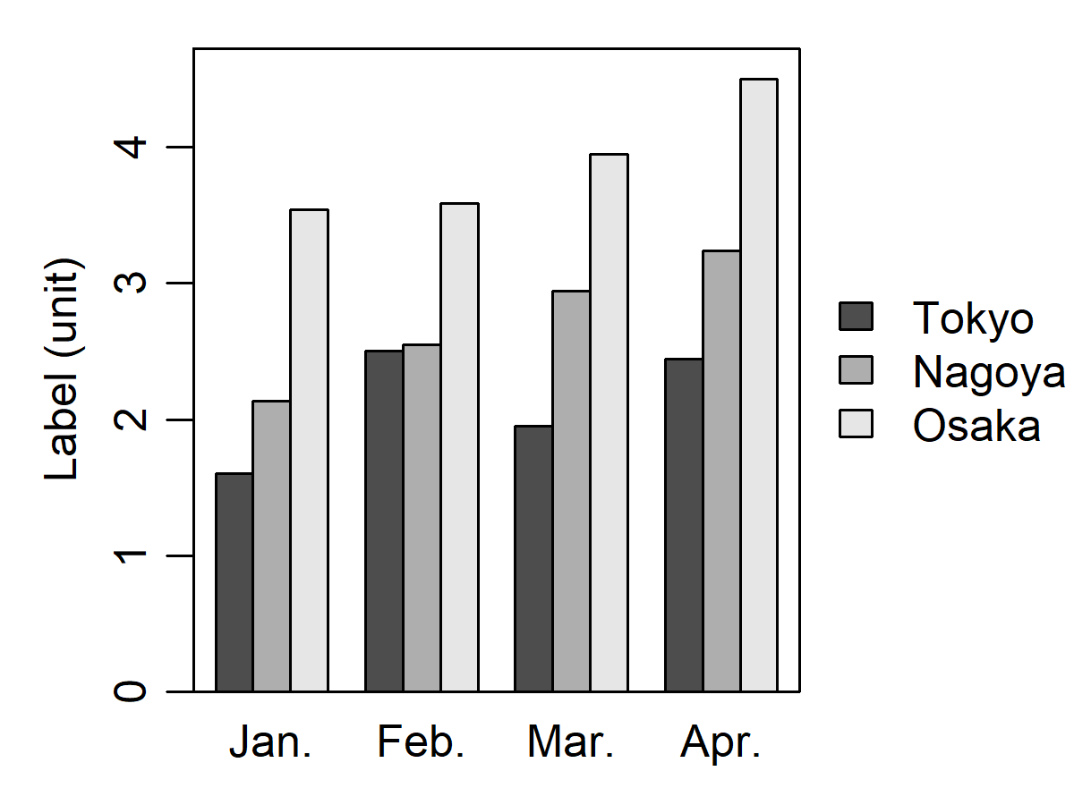
Figures and tables should be embedded within the abstract. Captions should be written in 10-point Times New Roman. In the text, refer to figures and tables using expressions such as “Fig. 1” or “Table 1.” Use the full word “Figure” at the beginning of a sentence. Color figures are allowed because the proceedings will be distributed online as a PDF file.

3. Submission
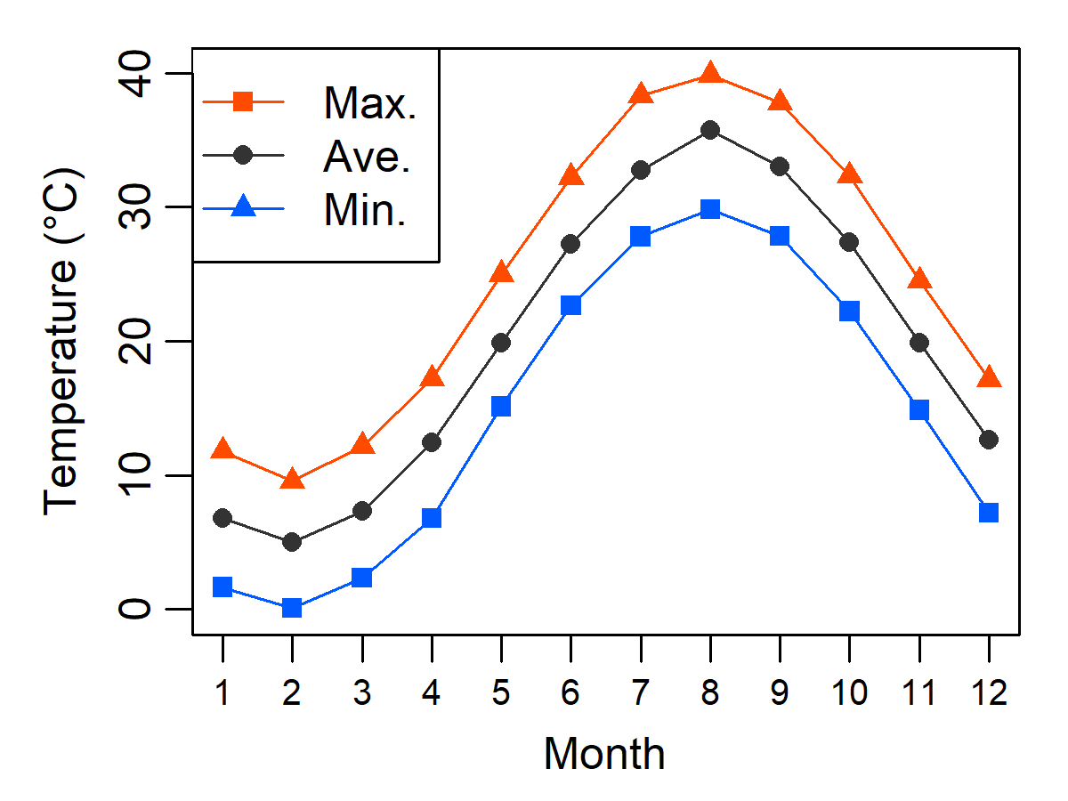
Authors are requested to submit the abstract as a PDF file by February 2, 2026. Any file name is allowed. Ensure that all fonts are embedded in the PDF and do not apply password protection.
Fig. 1. A black-and-white sample figure.
Fig. 2. A colored sample figure.

